**REPORT ON DENOISING**

Audio Signals are often contaminated by background environment noise and buzzing or humming noise from audio equipments. Audio denoising aims at attenuating the noise while retaining the underlying signals. Applications such as music and speech restoration are numerous.

We are using a summer circuit to add the noise to the signal with a limited bandwidth. We can use an LPF to generate a baseband signal. A triangular wave may have infinite harmonics, however on passing through an LPF creates a baseband signal with limited no. of harmonics. The time domain and frequency domain triangular signal passed through an LPF is shown in the figure below.

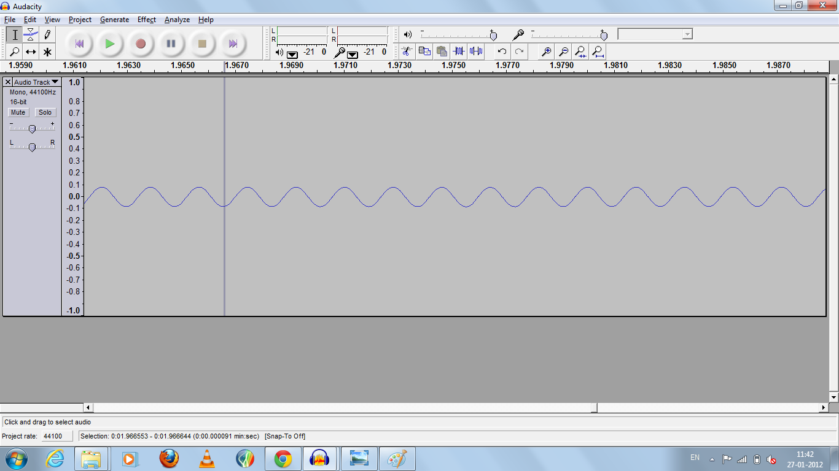

**Time domain triangular signal**

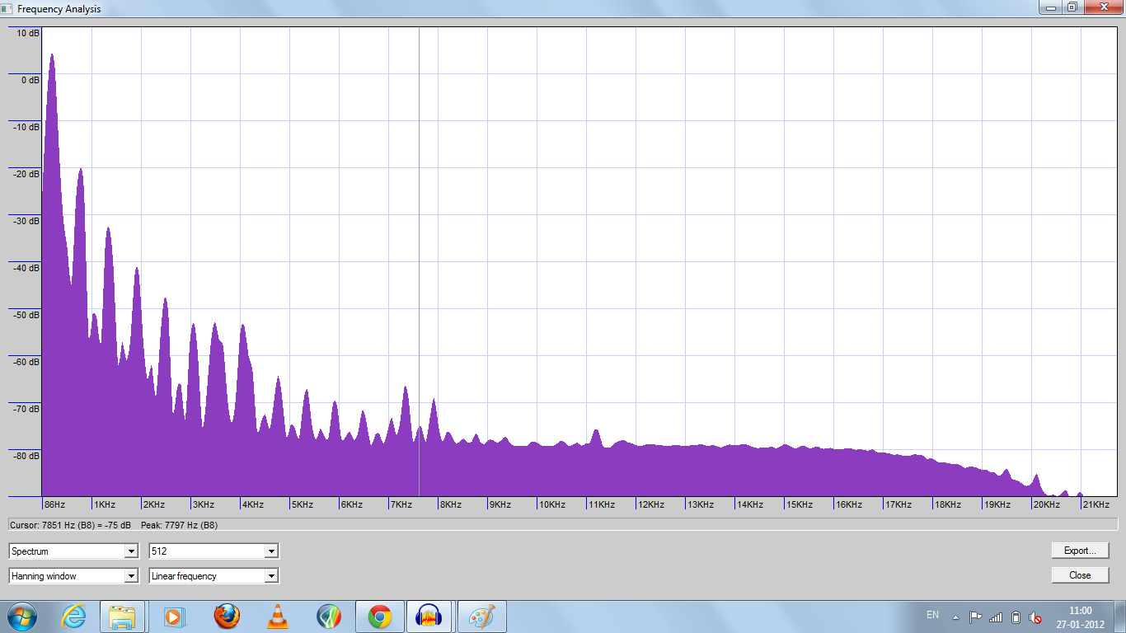

**Frequency domain representation of the baseband signal**

After adding baseband signal with the noise signal, we get the following signal. There are peaks corresponding to the frequencies of the baseband signal. There is a constant background white noise.

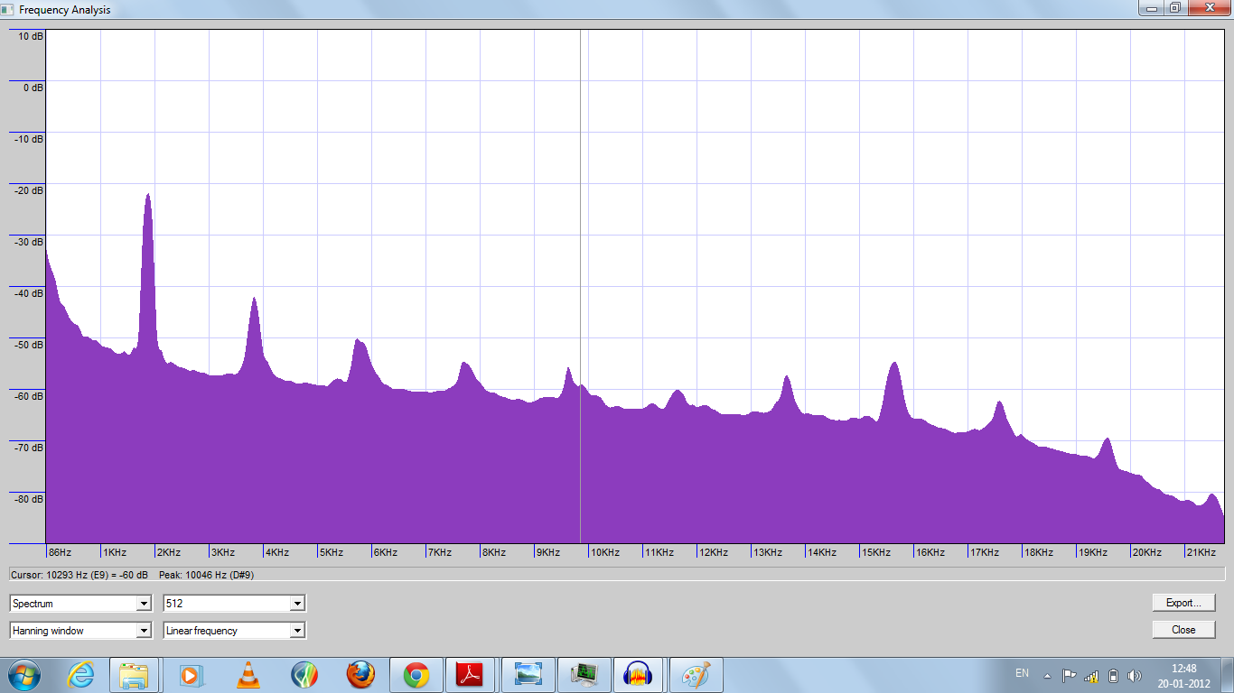

**Frequency domain of noise and baseband signal**

The noise in the signal can be filtered by using a low pass filter which is as shown in the figure:-

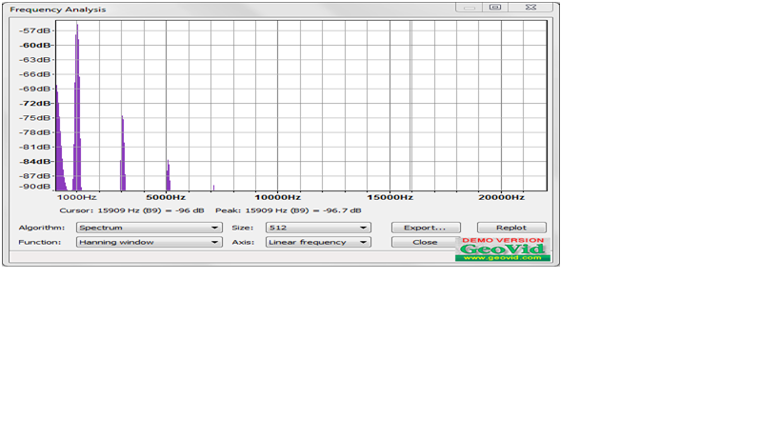

In this experiment, we are de-noising a noisy signal. Two types of noises were added to the speech signal:-

1. DC hums.
2. Electromagnetic interference.

But here we are just de-noising the DC hum part. DC hum is a constant humming sound that gets added to the signal of interest. The DC hum present in the given signal has a frequency component of 50 Hz and its harmonics.

The time-domain noisy signal is as shown in the figure:-

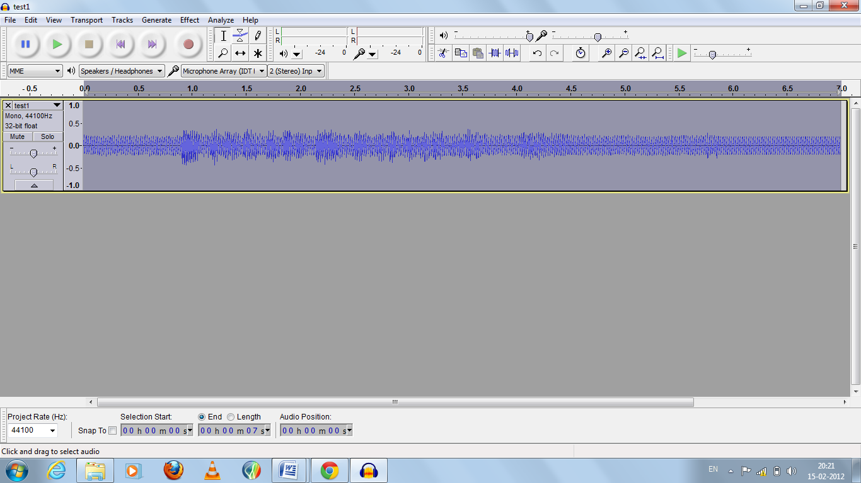

**Time domain representation of the signal**

The actual noise frequencies present in the signal are clear from the frequency domain representation of the signal. There are peaks in the power spectrum of the signal at 50 Hz and at various harmonics of 50 Hz.

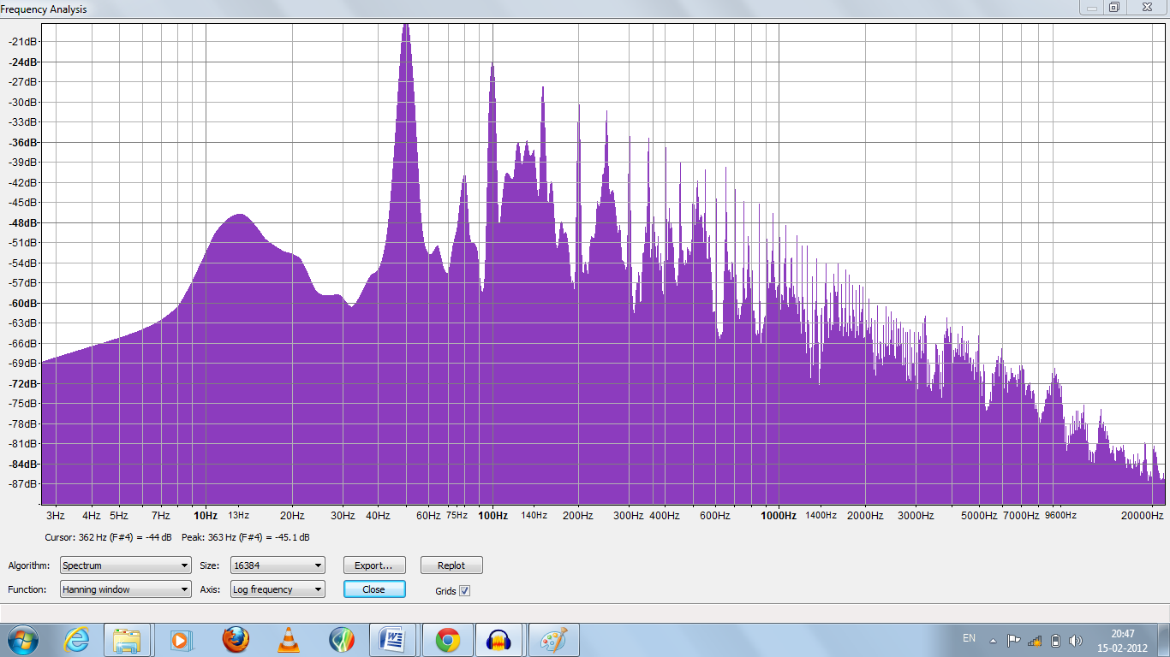

**Frequency spectrum of noisy signal**

**Filtered noisy signal**

The original signal after passing through a notch filter filters out the harmonics of the noisy signal. The output of the notch filter reduces the amplitude of the signal at 50 Hz and at its harmonics. The time domain is as shown in the figure. The filtering is not clear in the time domain.

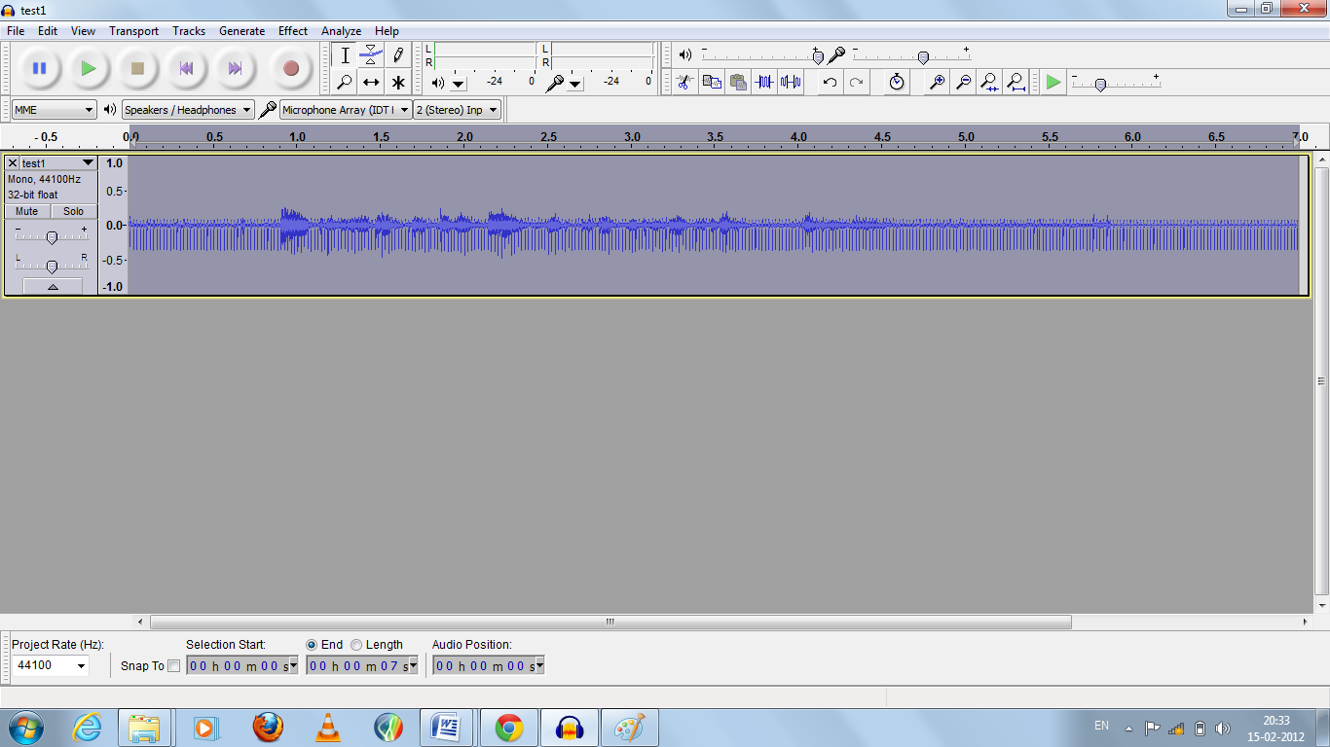

**Time domain filtered signal**

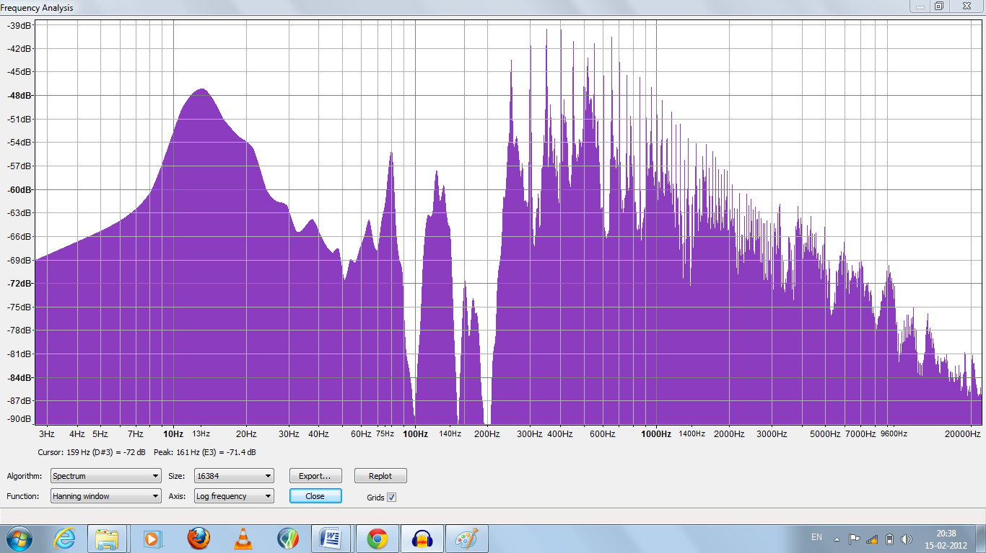

**Frequency domain filtered signal**

Conclusions:-

* The output signal is not completely de-noised as there are some DC hum components present this is because of the higher harmonics still present in the signal.
* The output signal has some other noise components this is because of the notch filter.
* It is not possible to completely remove the noise as the amplitude of the noise is much greater than the amplitude of original signal.